What is settlor-interested trust structures? Can you depict it into a flowchart?

ChatGPT said:
A settlor-interested trust is a type of trust where the settlor (the person who creates the trust and transfers assets into it) or their spouse/civil partner can benefit from the trust’s income or capital. These trusts are often set up for tax planning, but they have specific tax implications.

Key Features of Settlor-Interested Trusts:
- Control & Benefit – The settlor (or their spouse/civil partner) has an interest in the trust, meaning they may receive income or capital from it.
- Taxation – Any income generated within the trust is taxed as if it belongs to the settlor, even if they do not receive the income directly.
- Types:
  - Interest in Possession Trust – The settlor has a right to receive trust income.
  - Discretionary Trust – The settlor (or their spouse/civil partner) is included as a potential beneficiary.
Now, let me create a flowchart to illustrate how a settlor-interested trust operates.
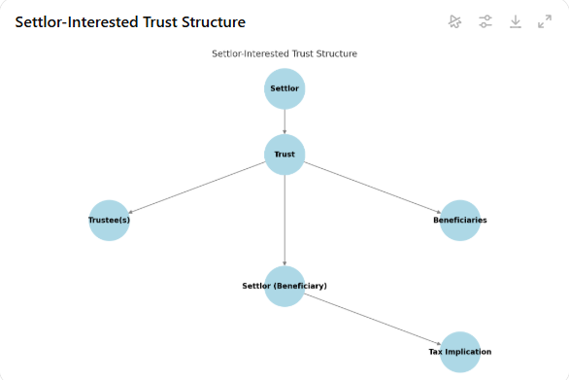
Here is a flowchart illustrating the settlor-interested trust structure. It shows how the settlor establishes the trust, how trustees manage it, and how the settlor or their spouse may benefit from it. The key point is that any income generated within the trust is taxed as if it belongs to the settlor.
Let me know if you need any modifications or further explanation! ​​

You said:
What is the main purpose in setting up trust?

ChatGPT said:
The main purpose of setting up a trust depends on the goals of the settlor, but generally, trusts are used for asset protection, wealth management, and tax planning. Below are the key purposes:

1. Asset Protection
- Protects assets from creditors, lawsuits, or financial mismanagement.
- Helps safeguard assets for future generations, ensuring they are used according to the settlor’s wishes.

2. Estate & Succession Planning
- Ensures smooth transfer of wealth to beneficiaries, avoiding probate delays.
- Maintains family wealth across generations while minimizing disputes.

3. Tax Planning
- Helps reduce inheritance tax (IHT) liability by transferring assets outside the settlor’s estate.
- Utilized to manage capital gains tax (CGT) and income tax liabilities.

4. Control Over Distribution
- Allows the settlor to specify how and when beneficiaries receive assets.
- Useful for managing assets for minors, disabled individuals, or those who may not be financially responsible.

5. Providing for Dependents
- Ensures financial security for children, spouses, or other dependents.
- Can be structured to provide long-term financial support.

6. Charitable Giving
- Used to establish charitable trusts to support causes the settlor cares about.
- Allows tax-efficient donations while ensuring funds are used properly.

7. Business Succession
- Helps transition business ownership in a structured manner.
- Protects family businesses from being split up or mismanaged after the owner’s death.
Your text discusses upcoming changes in the taxation of trusts from 6 April 2025, particularly regarding Foreign Income and Gains (FIG) in settlor-interested trusts and non-resident trusts.
Here’s a breakdown:
- End of Protection for Non-Domiciled Settlors
  - Currently, non-domiciled (non-dom) or deemed domiciled individuals may have some protection from UK tax on FIG that arises within a settlor-interested trust.
  - From 6 April 2025, this protection will no longer be available unless they qualify for the 4-year FIG regime (which applies to recent arrivals in the UK).
  - This means that non-domiciled or deemed domiciled settlors will be taxed on FIG arising in their trust, unless they qualify for the 4-year FIG regime.
- Existing Protected Non-Resident Trusts
  - FIG that arose before 6 April 2025 in a protected non-resident trust will remain untaxed unless:
    - A UK resident receives a distribution or benefit from the trust.
    - That UK resident is unable or chooses not to claim the 4-year FIG regime.
- Taxation of Pre-2025 FIG Distributions
  - If FIG arose in a trust structure before 6 April 2025, UK-resident settlors or beneficiaries (who do not qualify for the 4-year FIG regime) will be taxed on these amounts if the FIG is matched to distributions received.
  - This means that even though the FIG itself arose before the rule change, taxation depends on when the trust distributes the income or gains and whether the recipient qualifies for the 4-year regime.
Would you like me to simplify it further or expand on any particular aspect?
4o

You said:
How will the non-demiciled or deemed domiciled settlors be qualified for the 4-year FIG regime?

ChatGPT said:
The 4-year FIG regime is a transitional relief available from 6 April 2025 for certain new UK residents who were previously non-domiciled. This regime provides limited protection from UK taxation on foreign income and gains (FIG) during their initial years of UK residence.

Who Qualifies for the 4-Year FIG Regime?
A non-domiciled or deemed domiciled settlor can qualify for the 4-year FIG regime if they meet the following conditions:
- New UK Residency Condition
  - The individual must not have been UK tax resident in any of the three tax years before the first tax year of UK residence in or after 2025/26.
  - Example: If an individual becomes UK tax resident in 2025/26, they must not have been UK tax resident in 2022/23, 2023/24, or 2024/25.
- FIG Protection for Four Tax Years
  - If eligible, the individual can benefit from the remittance basis without the usual election for their first four consecutive tax years of UK residence.
  - During these four years, foreign income and gains (FIG) will not be taxed in the UK unless remitted.
- Application to Trusts
  - If a non-domiciled or deemed domiciled settlor qualifies for this 4-year FIG regime, they will not be taxed immediately on FIG arising in a settlor-interested trust (unless they remit it to the UK).
  - However, after the four years end, all FIG will be taxed on an arising basis, meaning all worldwide income and gains will be subject to UK tax as they arise.

What Happens After the 4 Years?
Once the 4-year FIG regime expires, the individual will be taxed as a normal UK resident on an arising basis, meaning:
- They will no longer benefit from any special treatment of foreign income and gains.
- FIG within settlor-interested trusts will be taxed immediately on the settlor as it arises.
- Distributions or benefits from any non-resident trusts may also be taxed based on the matching rules.

Key Takeaways
- The 4-year FIG regime is available to individuals who have not been UK resident in the last three years before becoming UK resident.
- It protects non-domiciled individuals from UK tax on foreign income and gains for four tax years, unless remitted.
- If a settlor qualifies, the FIG in a settlor-interested trust may remain protected during these four years.
- After four years, the individual will be taxed on their worldwide income and gains as they arise

